

**GYM MANAGEMENT SYSTEM**

**GROUP MEMBERS:**

**HASAN, MD. SIAM 14-27460-2**

**NOMAN, ABDULLAH AL 15-30873-3**

**HOSSAIN, MD. MANWAR 16-32092-2**

**FAHIM, SADMAN CHOWDHURY 16-32374-2**

**DAS, DIP 16-32482-2**

**COURSE NAME: INTRODUCTION TO DATA BASE**

**SECTION: I**

**FACULTY NAME: JUENA AHMED NOSHIN**

**Introduction:**

Our project is about a gym management system. We know in a gym there are various kinds of data that is need to keep safe. If we use a digital system for that then it will be very efficient. We know in a normal gym there are gym customer, staff, instrument etc. are exist. So in our data base we will keep the information about them. Additionally we will save the data about income and expense. So at last we hope that it will help a gym to maintain its activity efficiently.

**Scenario Description:**

In our data base system we will work about the client, equipment, staffs, trainers, locker, food chart, payment and skill of that trainer. In the client section there are name, gender, joining date, shift, mobile number, birthday and a unique client id. In the staff section there are also staff name, address, salary, joining date, staff role, mobile number and a unique staff id. In the equipment section there are equipment name, equipment quantity, status and a unique equipment id. A client can use more than one equipment and an equipment can be used by more than one client. In the payment section there are payment is, date, amount and the customer id as a foreign key. In payment type there are payment name and a unique payment id. Payment can be paid by BKASH, CASH and CREDIT CARD. The unique payment id will be used as a foreign key in the Payment table. In the Customer exercise table have exercise name, time and a unique exercise id. The client id is the foreign key in this table. In the trainer section there are trainer name, mobile number, and address, joining date, shift and a unique trainer id. There are a Trainer skill table related to trainer table. A trainer can have more than one skill so in the table there will be trainer id and skill id. There will also be a skill table where skill name and a unique skill id will be available. In a quality gym locker system is important. In our data base there are a section for locker system which is containing locker id and client id. Locker table is related with client table and the client id is will be used as foreign key. A locker can be used by only one client. Diet routine is very important for the gym client so we keep a diet table in our data base. In the diet table there are three attributes which are diet id, unit and the client id is the foreign key. Food table is related with diet table which is containing food name, unit type and a unique food id. A staff or a trainer can help more than one client and a client can get help from more than one staff or trainer.

**ER Diagram:**

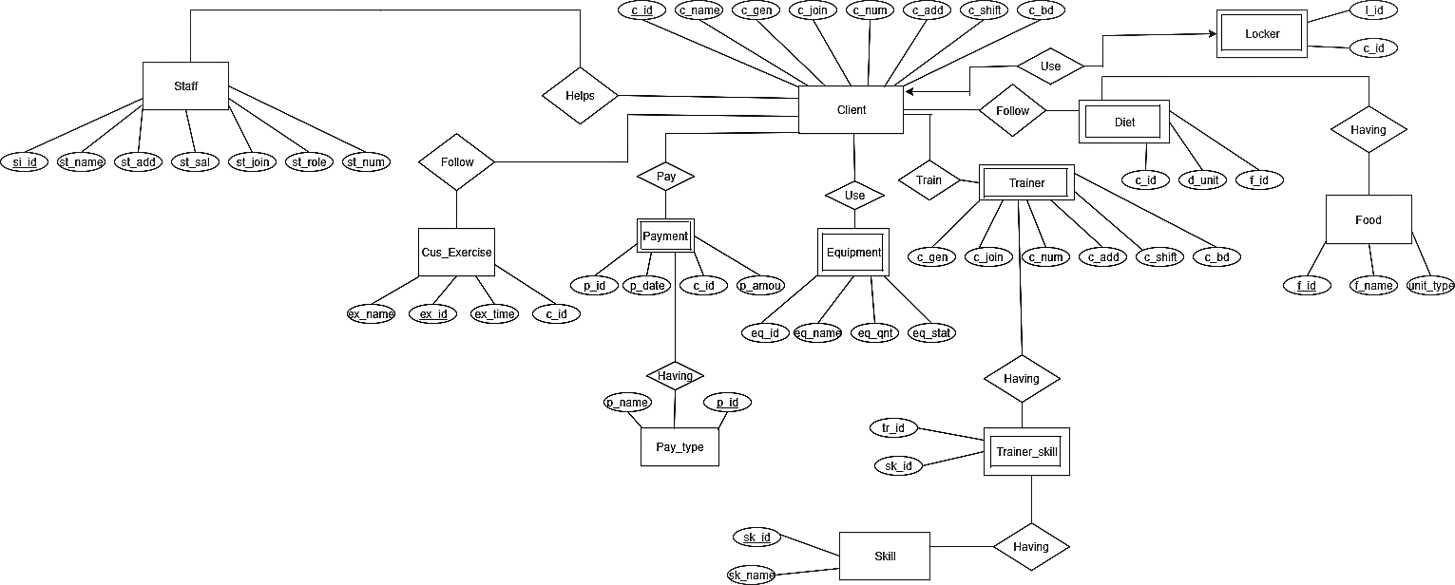

**Normalization:**

The Normalization have been done below from 1NF to 3NF.

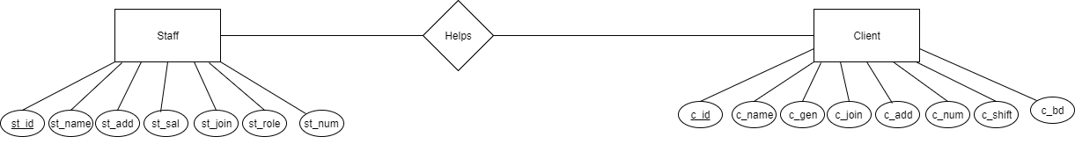

**1NF**

Helps (c_id, c_name, c_gen, c_join, c_add, c_num, c_shift, c_bd, st_id, st_name, st_add, st_sal, st_join, st_role, st_num)

**2NF**

(c_id, c_name, c_gen, c_join, c_add, c_num, c_shift, c_bd)

(st_id, st_name, st_add, st_sal, st_join, st_role, st_num)

(c_id, st_id)

**3NF**

Already in 2NF

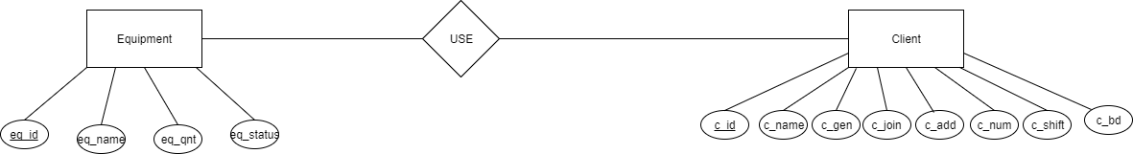

**1NF**

Use (c_id, c_name, c_gen, c_join, c_add, c_num, c_shift, c_bd, eq_id, eq_name, eq_qnt, eq_status)

**2NF**

(c_id, c_name, c_gen, c_join, c_add, c_num, c_shift, c_bd)

(eq_id, eq_name, eq_qnt, eq_status)

(c_id, eq_id)

**3NF**

Already in 2NF

**Final Normalization:**

**#1NF:**

Client (c_id, c_name, c_gender, c_join, c_num, c-add, c_shift, c_bd)

Staff (st_id, st_name, st_add, st_salary, st_join, st_role, st_num)

Trainer (t_id, t_name, t_num, t_add, t_join, t_shift)   
  
**#2NF:**

Client (c_id, c_name, c_gender, c_join, c_num, c-add, c_shift, c_bd)

Staff (st_id, st_name, st_add, st_salary, st_join, st_role, st_num)

Trainer (t_id, t_name, t_num, t_add, t_join, t_shift)

Payment (p_id, p_date, c_id, p_amount)

Cus_Exercise (ex_id, ex_name, cex_time, c_id)

Equipment (eq_id, eq_name, eq_qnt, eq_status)

Trainer_skill (tr_id, sk_id)  
Diet (c_id, d_unit, d_id)  
  
**#3NF:**Client (c_id, c_name ,c_gender, c_join, c_num, c-add, c_shift, c_bd)

Staff (st_id, st_name, st_add, st_salary, st_join, st_role, st_num)

Trainer (t_id, t_name, t_num, t_add, t_join, t_shift)

Payment (p_id, p_date, c_id, p_amount)

Payment_type (p_id, p_name)

Cus_exer (ex_id, ex_time, ex__name, c_id)

Equipment (eq_id, eq_name, eq_qnt, eq_status)

Trainer_skill (tr_id, sk_id)   
Diet (c_id, d_unit, d_id)

Skill (sk_id, sk_name)   
Locker (l_id, c_id)  
Food (f_id, f_name, unit_type)

**Table Creation**

Here the screen shoot of tables for this project.

**Client Table:**

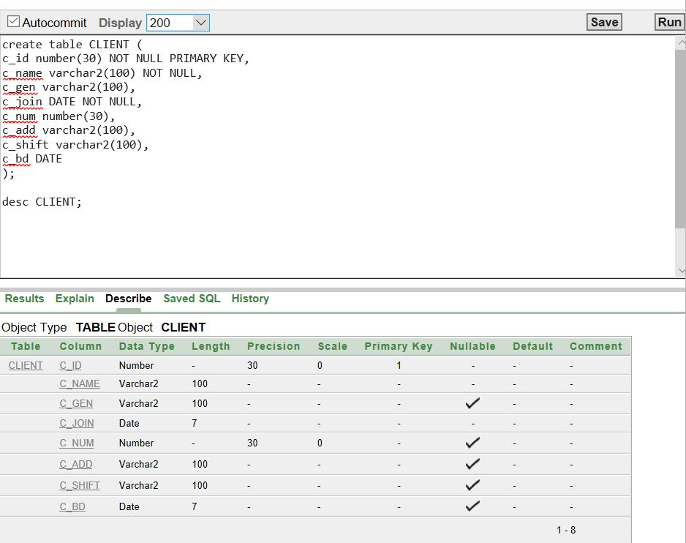

**Cus_Exercise Table:** 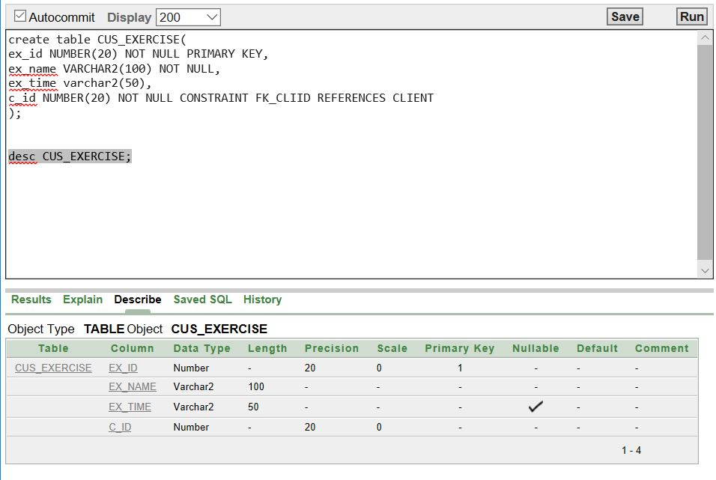

**Diet Table:**

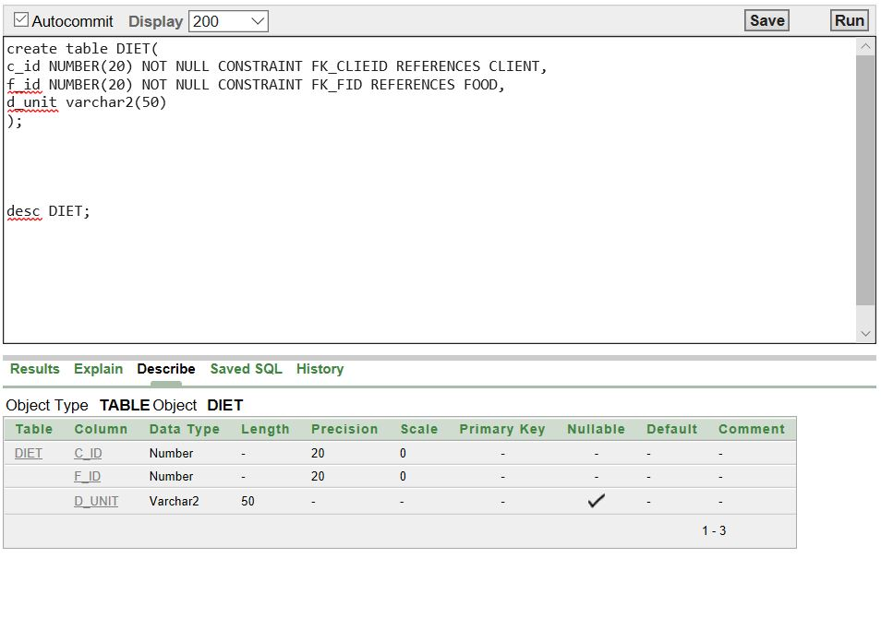

**Equipment Table:**

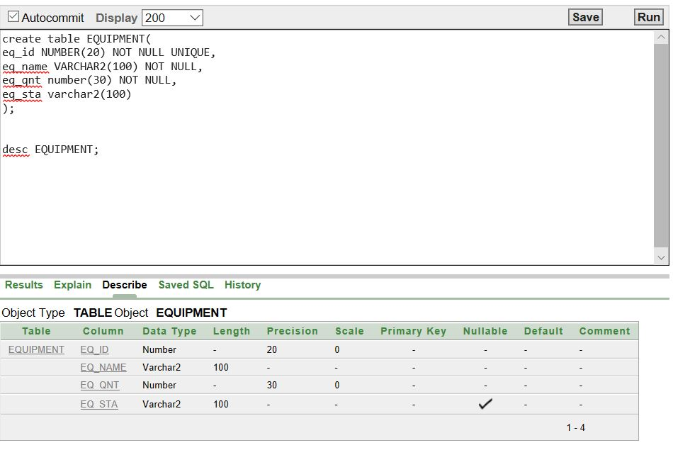

**Food Table:**

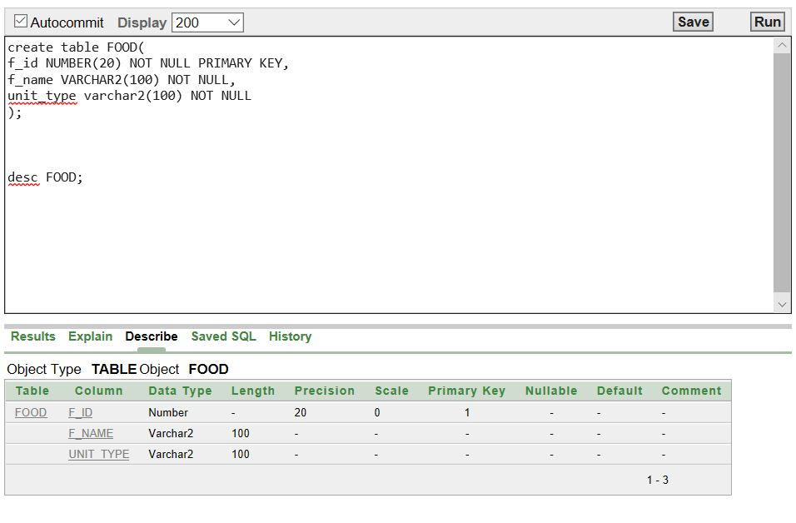

**Locker Table:**

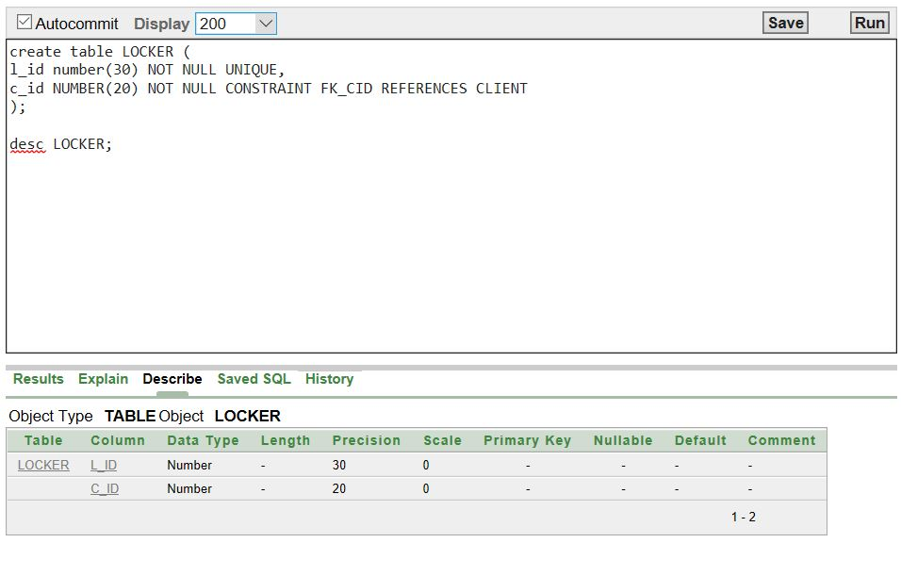

**Payment Table:**

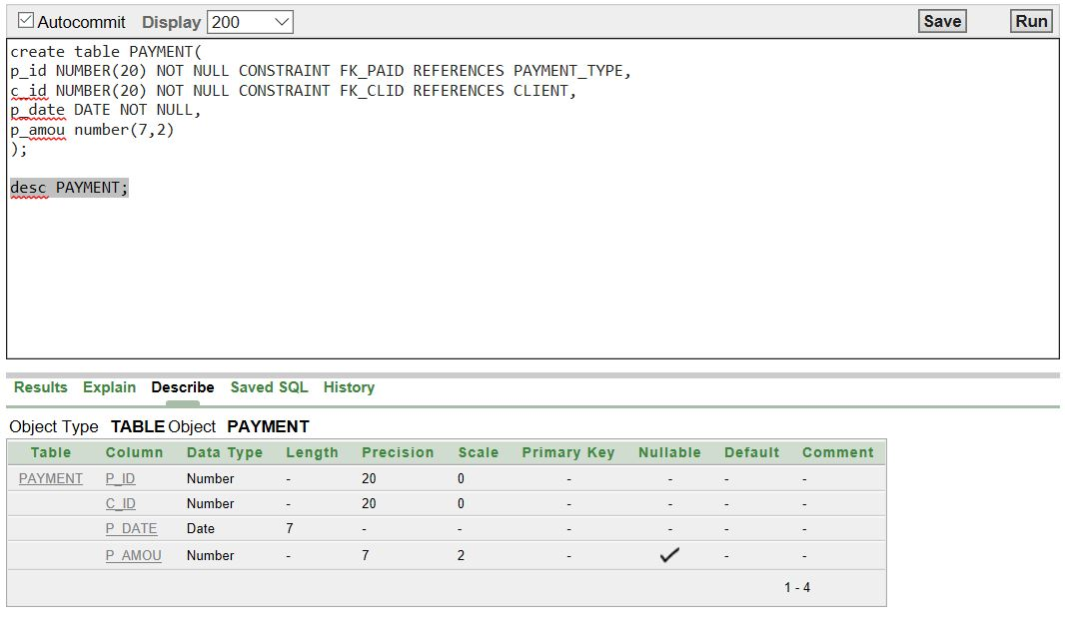

**Payment_Type Table:**

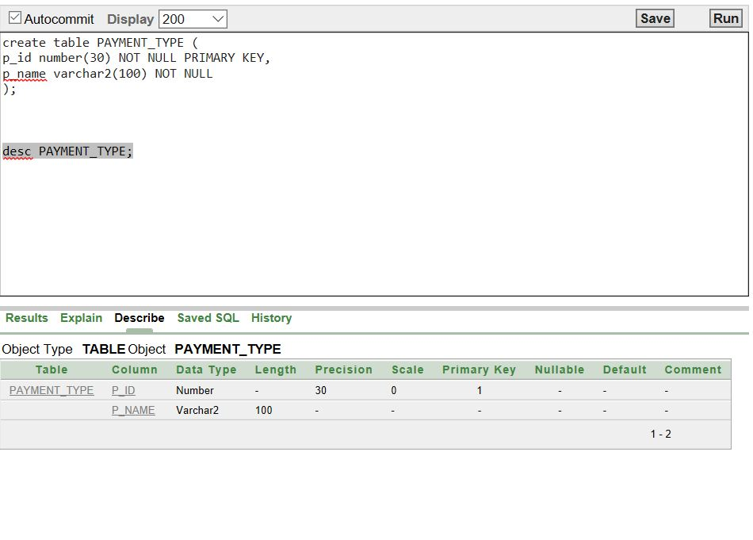

**Skill Table:**

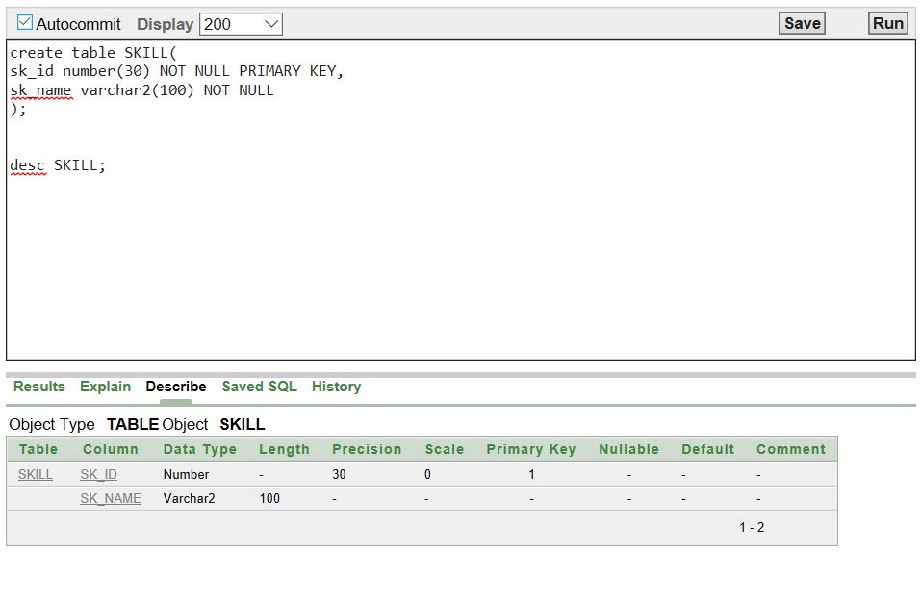

**Staff Table:**

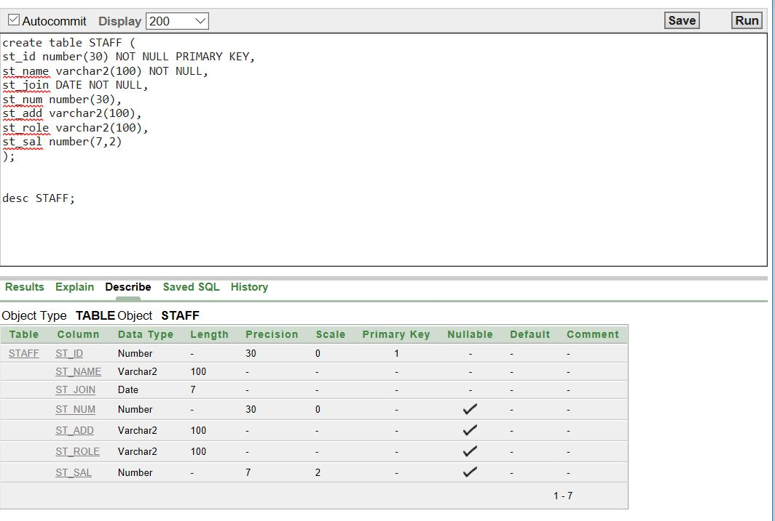

**Trainer Table:**

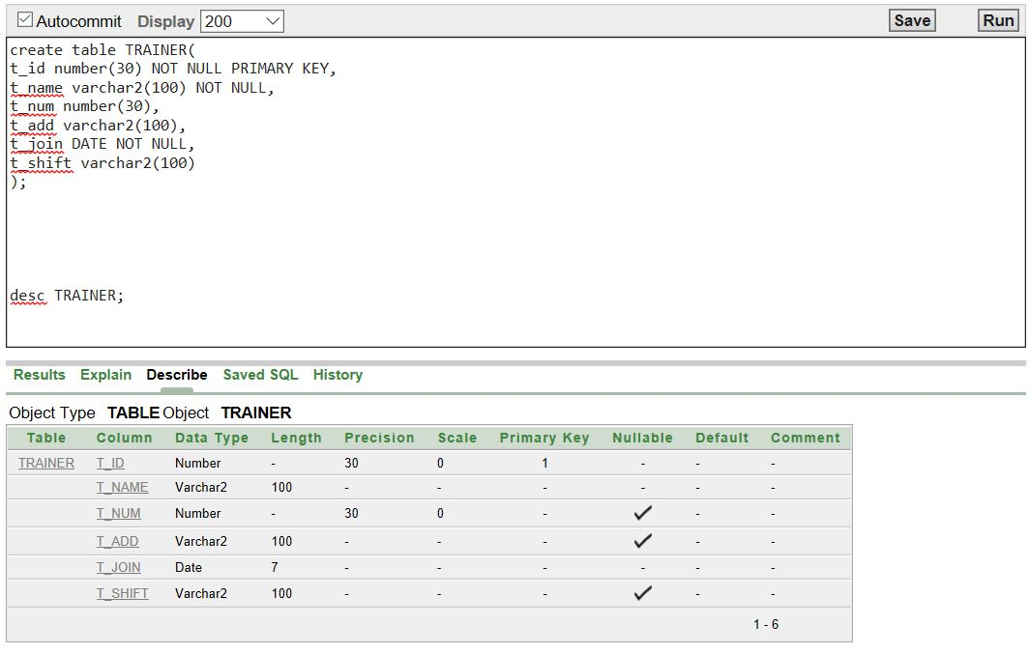

**Trainer_Skill Table:**

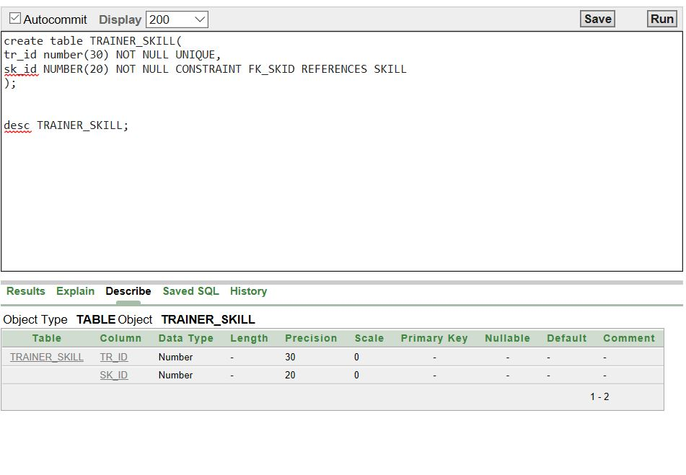

Here the qureis of those tables:

**# CLIENT Table**

create table CLIENT (

c_id number(30) NOT NULL PRIMARY KEY,

c_name varchar2(100) NOT NULL,

c_gen varchar2(100),

c_join DATE NOT NULL,

c_num number(30),

c_add varchar2(100),

c_shift varchar2(100),

c_bd DATE);

**# STAFF TABLE**

create table STAFF (

st_id number(30) NOT NULL PRIMARY KEY,

st_name varchar2(100) NOT NULL,

st_join DATE NOT NULL,

st_num number(30),

st_add varchar2(100),

st_role varchar2(100),

st_sal number(7,2));

**# LOCKER TABLE**

create table LOCKER (

l_id number(30) NOT NULL UNIQUE,

c_id NUMBER(20) NOT NULL CONSTRAINT FK_CID REFERENCES CLIENT);

**#TRAINER TABLE**

create table TRAINER(

t_id number(30) NOT NULL PRIMARY KEY,

t_name varchar2(100) NOT NULL,

t_num number(30),

t_add varchar2(100),

t_join DATE NOT NULL,

t_shift varchar2(100));

**#SKILL Table**

create table SKILL(

sk_id number(30) NOT NULL PRIMARY KEY,

sk_name varchar2(100) NOT NULL);

**#Trainer_Skill Table**

create table TRAINER_SKILL(

tr_id number(30) NOT NULL UNIQUE,

sk_id NUMBER(20) NOT NULL CONSTRAINT FK_SKID REFERENCES SKIL);

**#PAYMENT_TYEP Table**

create table PAYMENT_TYPE (

p_id number(30) NOT NULL PRIMARY KEY,

p_name varchar2(100) NOT NULL);

**#PAYMENT Table**

create table PAYMENT(

p_id NUMBER(20) NOT NULL CONSTRAINT FK_PAID REFERENCES PAYMENT_TYPE,

c_id NUMBER(20) NOT NULL CONSTRAINT FK_CLID REFERENCES CLIENT,

p_date DATE NOT NULL,

p_amou number(7,2) );

**#EQUIPMENT Table**

create table EQUIPMENT(

eq_id NUMBER(20) NOT NULL UNIQUE,

eq_name VARCHAR2(100) NOT NULL,

eq_qnt number(30) NOT NULL,

eq_sta varchar2(100) );

**#CUS_EXERCISE Table**

create table CUS_EXERCISE(

ex_id NUMBER(20) NOT NULL PRIMARY KEY,

ex_name VARCHAR2(100) NOT NULL,

ex_time varchar2(50),

c_id NUMBER(20) NOT NULL CONSTRAINT FK_CLIID REFERENCES CLIENT);

**#FOOD Table**

create table FOOD(

f_id NUMBER(20) NOT NULL PRIMARY KEY,

f_name VARCHAR2(100) NOT NULL,

unit_type varchar2(100) NOT NULL);

**#DIET Table**

create table DIET(

c_id NUMBER(20) NOT NULL CONSTRAINT FK_CLIEID REFERENCES CLIENT,

f_id NUMBER(20) NOT NULL CONSTRAINT FK_FID REFERENCES FOOD,

d_unit varchar2(50));

**Data Insertion**

**Client Table:**

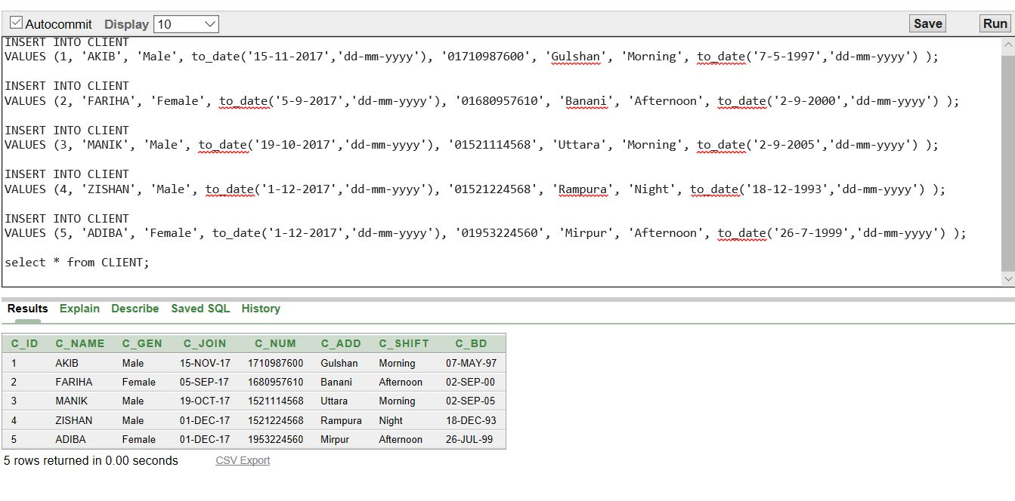

**Cus_Exercise Table:**

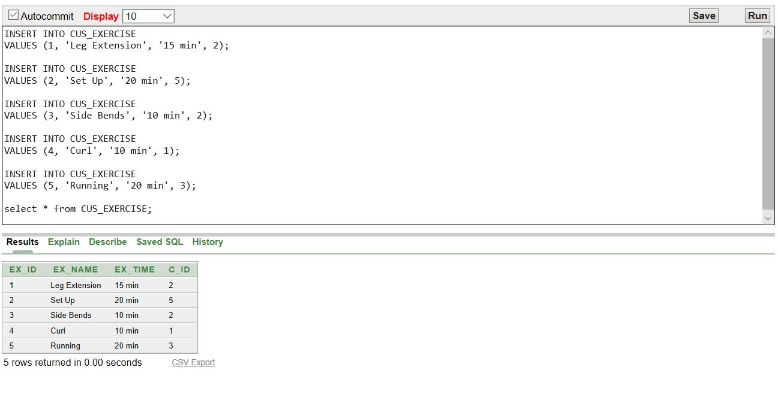

**Diet Table:**

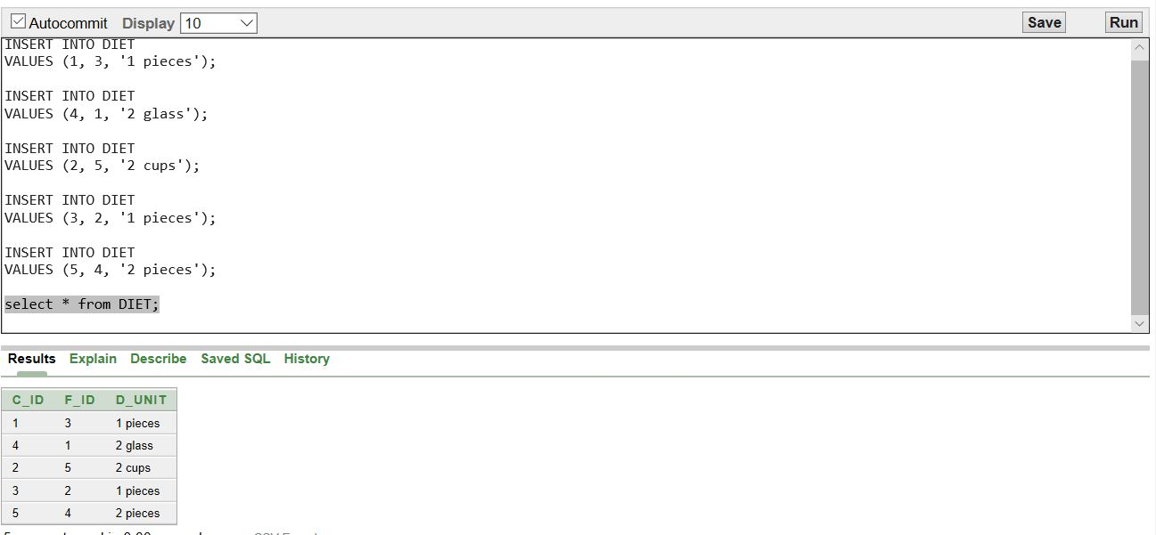

**Equipment Table:**

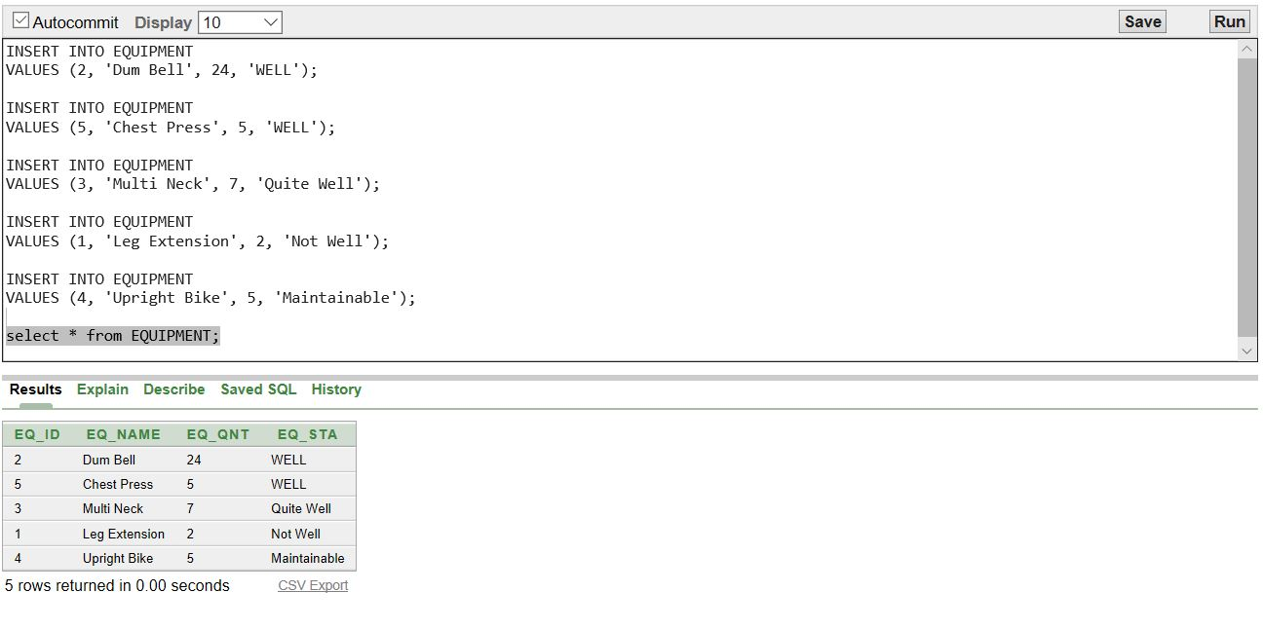

**Food Table:**

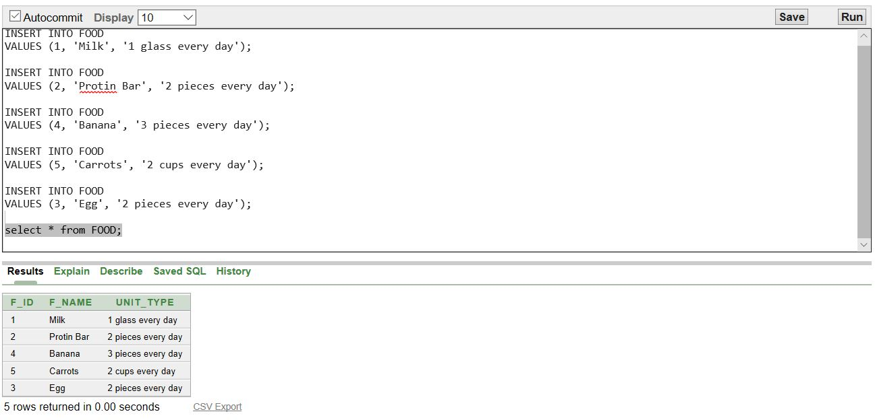

**Locker Table:**

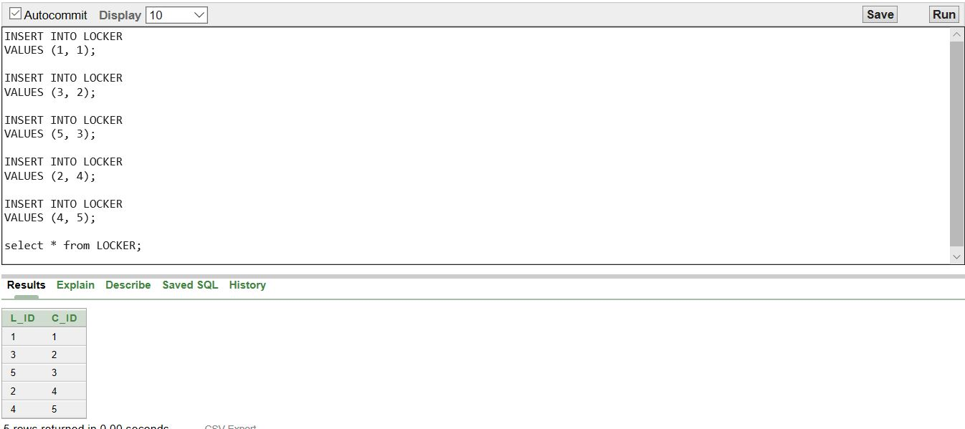

**Payment_Type Table:**

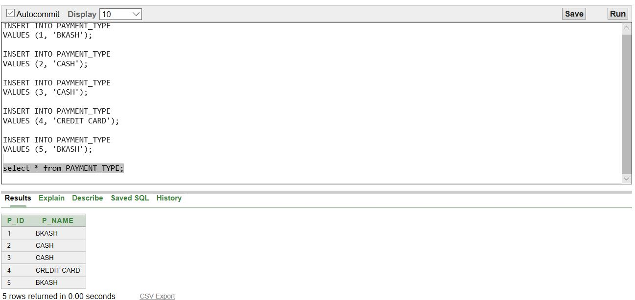

**Payment Table:**

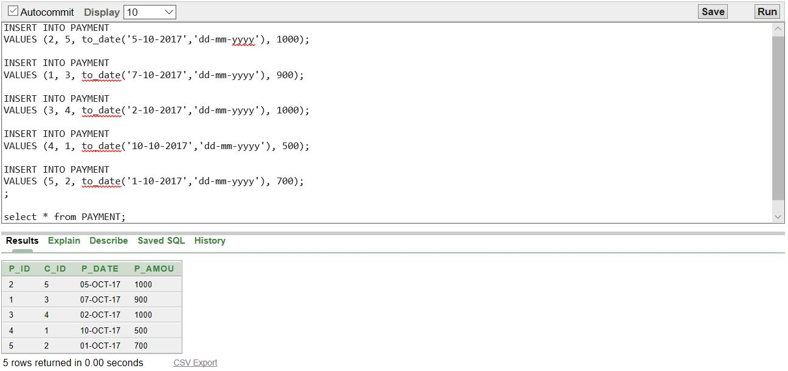

**Skill Table:**

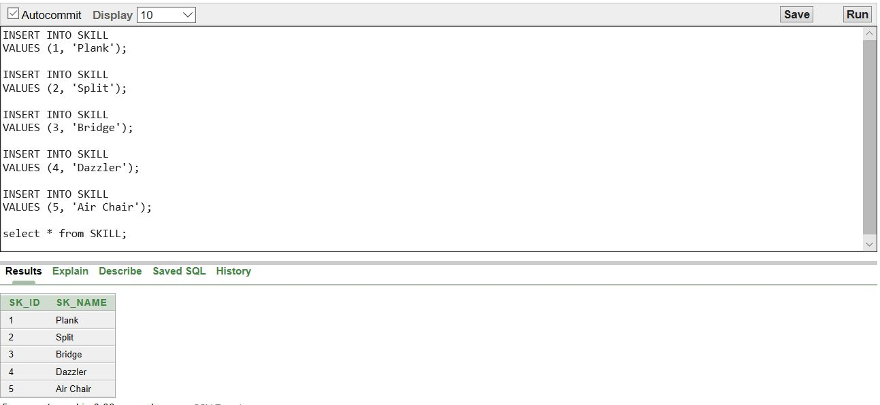

**Staff Table:**

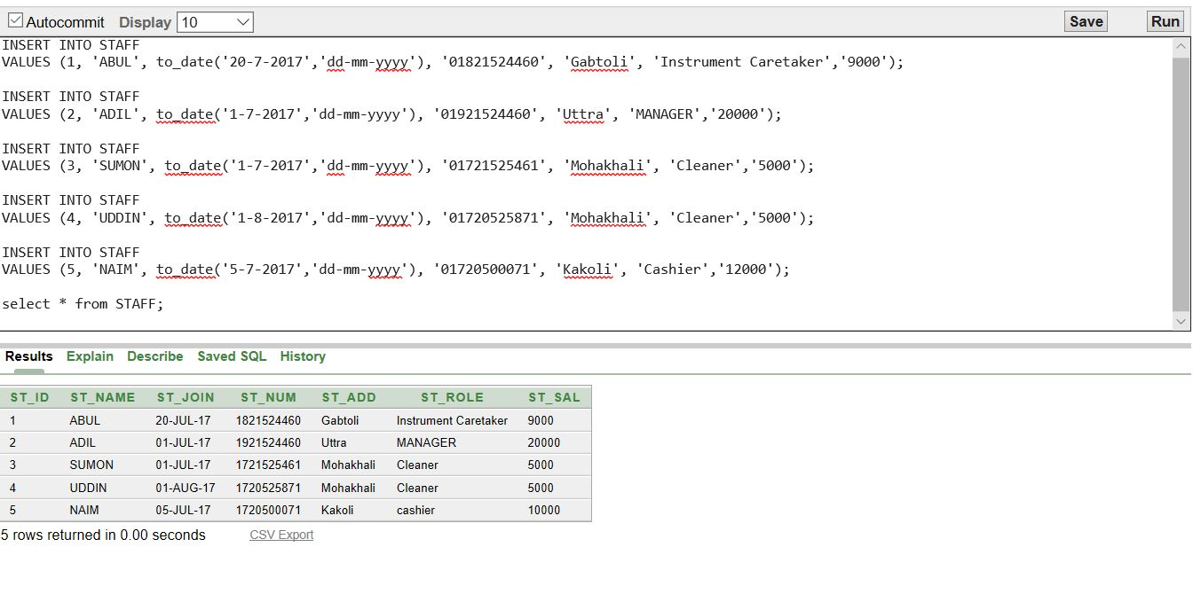

**Trainer_Skill Table:**

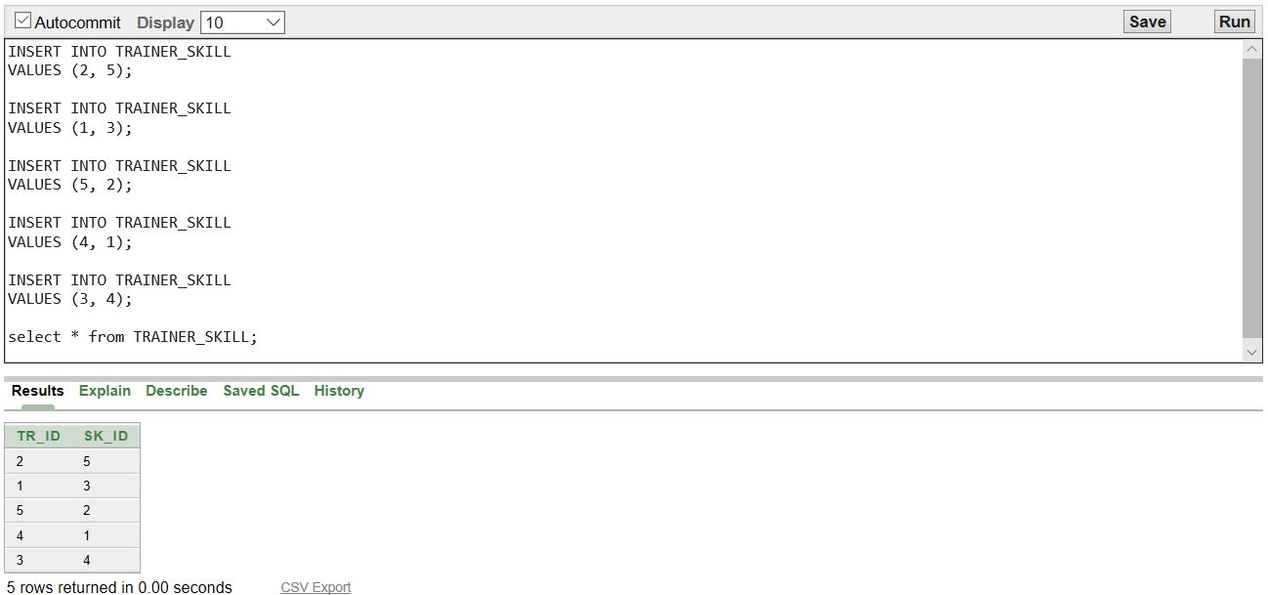

**Trainer Table:**

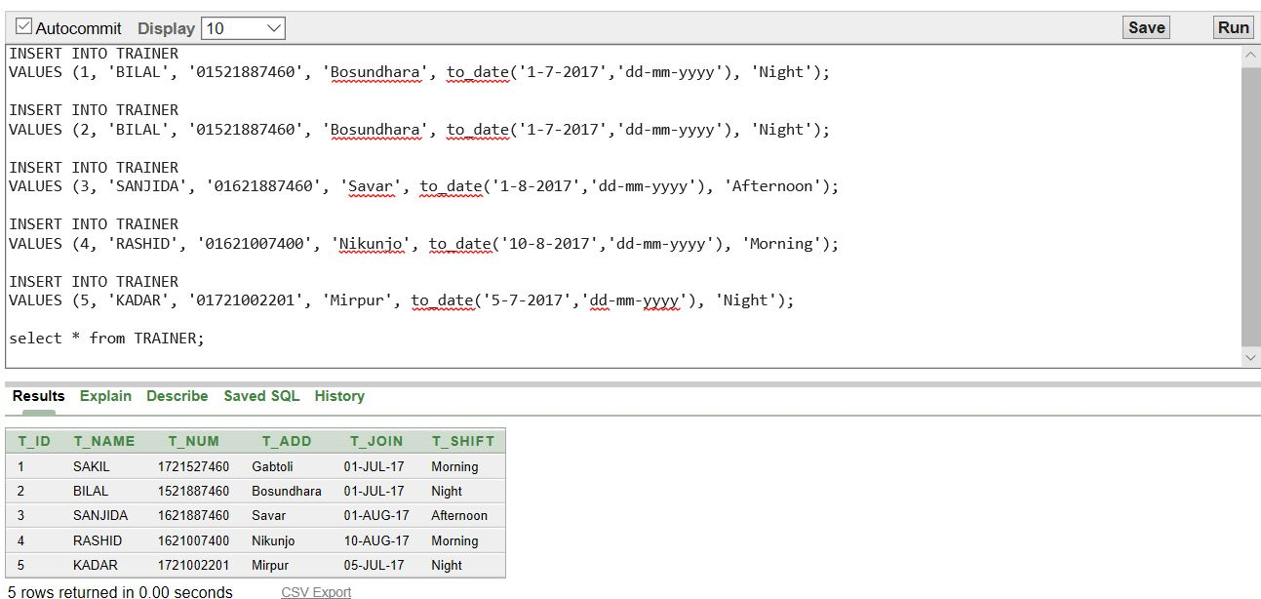

Here are the Insert queries for those tables:

**# Insert client**

INSERT INTO CLIENT

VALUES (1, 'AKIB', 'Male', to_date('15-11-2017','dd-mm-yyyy'), '01710987600', 'Gulshan', 'Morning', to_date('7-5-1997','dd-mm-yyyy') );

INSERT INTO CLIENT

VALUES (2, 'FARIHA', 'Female', to_date('5-9-2017','dd-mm-yyyy'), '01680957610', 'Banani', 'Afternoon', to_date('2-9-2000','dd-mm-yyyy') );

INSERT INTO CLIENT

VALUES (3, 'MANIK', 'Male', to_date('19-10-2017','dd-mm-yyyy'), '01521114568', 'Uttara', 'Morning', to_date('2-9-2005','dd-mm-yyyy') );

INSERT INTO CLIENT

VALUES (4, 'ZISHAN', 'Male', to_date('1-12-2017','dd-mm-yyyy'), '01521224568', 'Rampura', 'Night', to_date('18-12-1993','dd-mm-yyyy') );

INSERT INTO CLIENT

VALUES (5, 'ADIBA', 'Female', to_date('1-12-2017','dd-mm-yyyy'), '01953224560', 'Mirpur', 'Afternoon', to_date('26-7-1999','dd-mm-yyyy') );

**#Insert Staff**

INSERT INTO STAFF

VALUES (1, 'ABUL', to_date('20-7-2017','dd-mm-yyyy'), '01821524460', 'Gabtoli', 'Instrument Caretaker','9000');

INSERT INTO STAFF

VALUES (2, 'ADIL', to_date('1-7-2017','dd-mm-yyyy'), '01921524460', 'Uttra', 'MANAGER','20000');

INSERT INTO STAFF

VALUES (3, 'SUMON', to_date('1-7-2017','dd-mm-yyyy'), '01721525461', 'Mohakhali', 'Cleaner','5000');

INSERT INTO STAFF

VALUES (4, 'UDDIN', to_date('1-8-2017','dd-mm-yyyy'), '01720525871', 'Mohakhali', 'Cleaner','5000');

INSERT INTO STAFF

VALUES (5, 'NAIM', to_date('5-7-2017','dd-mm-yyyy'), '01720500071', 'Kakoli', 'Cashier','12000');

**#Insert LOCKER**

INSERT INTO LOCKER

VALUES (1, 1);

INSERT INTO LOCKER

VALUES (3, 2);

INSERT INTO LOCKER

VALUES (5, 3);

INSERT INTO LOCKER

VALUES (2, 4);

INSERT INTO LOCKER

VALUES (4, 5);

**#Insert Trainer**

INSERT INTO TRAINER

VALUES (1, 'BILAL', '01521887460', 'Bosundhara', to_date('1-7-2017','dd-mm-yyyy'), 'Night');

INSERT INTO TRAINER

VALUES (2, 'BILAL', '01521887460', 'Bosundhara', to_date('1-7-2017','dd-mm-yyyy'), 'Night');

INSERT INTO TRAINER

VALUES (3, 'SANJIDA', '01621887460', 'Savar', to_date('1-8-2017','dd-mm-yyyy'), 'Afternoon');

INSERT INTO TRAINER

VALUES (4, 'RASHID', '01621007400', 'Nikunjo', to_date('10-8-2017','dd-mm-yyyy'), 'Morning');

INSERT INTO TRAINER

VALUES (5, 'KADAR', '01721002201', 'Mirpur', to_date('5-7-2017','dd-mm-yyyy'), 'Night');

**#Insert Skill**

INSERT INTO SKILL

VALUES (1, 'Plank');

INSERT INTO SKILL

VALUES (2, 'Split');

INSERT INTO SKILL

VALUES (3, 'Bridge');

INSERT INTO SKILL

VALUES (4, 'Dazzler');

INSERT INTO SKILL

VALUES (5, 'Air Chair');

**#Insert Trainer_Skill**

INSERT INTO TRAINER_SKILL

VALUES (2, 5);

INSERT INTO TRAINER_SKILL

VALUES (1, 3);

INSERT INTO TRAINER_SKILL

VALUES (5, 2);

INSERT INTO TRAINER_SKILL

VALUES (4, 1);

INSERT INTO TRAINER_SKILL

VALUES (3, 4);

**#Insert Payment_type**

INSERT INTO PAYMENT_TYPE

VALUES (1, 'BKASH');

INSERT INTO PAYMENT_TYPE

VALUES (2, 'CASH');

INSERT INTO PAYMENT_TYPE

VALUES (3, 'CASH');

INSERT INTO PAYMENT_TYPE

VALUES (4, 'CREDIT CARD');

INSERT INTO PAYMENT_TYPE

VALUES (5, 'BKASH');

**#Insert Payment**

INSERT INTO PAYMENT

VALUES (2, 5, to_date('5-10-2017','dd-mm-yyyy'), 1000);

INSERT INTO PAYMENT

VALUES (1, 3, to_date('7-10-2017','dd-mm-yyyy'), 900);

INSERT INTO PAYMENT

VALUES (3, 4, to_date('2-10-2017','dd-mm-yyyy'), 1000);

INSERT INTO PAYMENT

VALUES (4, 1, to_date('10-10-2017','dd-mm-yyyy'), 500);

INSERT INTO PAYMENT

VALUES (5, 2, to_date('1-10-2017','dd-mm-yyyy'), 700);

**#Insert Equipment**

INSERT INTO EQUIPMENT

VALUES (2, 'Dum Bell', 24, 'WELL');

INSERT INTO EQUIPMENT

VALUES (5, 'Chest Press', 5, 'WELL');

INSERT INTO EQUIPMENT

VALUES (3, 'Multi Neck', 7, 'Quite Well');

INSERT INTO EQUIPMENT

VALUES (1, 'Leg Extension', 2, 'Not Well');

INSERT INTO EQUIPMENT

VALUES (4, 'Upright Bike', 5, 'Maintainable');

**#Insert CUS_EXERCISE**

INSERT INTO CUS_EXERCISE

VALUES (1, 'Leg Extension', '15 min', 2);

INSERT INTO CUS_EXERCISE

VALUES (2, 'Set Up', '20 min', 5);

INSERT INTO CUS_EXERCISE

VALUES (3, 'Side Bends', '10 min', 2);

INSERT INTO CUS_EXERCISE

VALUES (4, 'Curl', '10 min', 1);

INSERT INTO CUS_EXERCISE

VALUES (5, 'Running', '20 min', 3);

**#Insert Food**

INSERT INTO FOOD

VALUES (1, 'Milk', '1 glass every day');

INSERT INTO FOOD

VALUES (2, 'Protin Bar', '2 pieces every day');

INSERT INTO FOOD

VALUES (4, 'Banana', '3 pieces every day');

INSERT INTO FOOD

VALUES (5, 'Carrots', '2 cups every day');

INSERT INTO FOOD

VALUES (3, 'Egg', '2 pieces every day');

**#Insert Diet**

INSERT INTO DIET

VALUES (1, 3, '1 pieces');

INSERT INTO DIET

VALUES (4, 1, '2 glass');

INSERT INTO DIET

VALUES (2, 5, '2 cups');

INSERT INTO DIET

VALUES (3, 2, '1 pieces');

INSERT INTO DIET

VALUES (5, 4, '2 pieces');

**Query Writing**

Here some query and screen shot of some questions for our project.

**##SINGLE ROW FUNCTION QUERIES:**

**1)** **Calculate and display the rounded salary of staff Abul and Uddin after dividing salary by 150?**

**Answer:**

**select round(st_sal)/150**

**from STAFF**

**where st_name = 'ABUL'**

**or st_name = 'UDDIN'**;

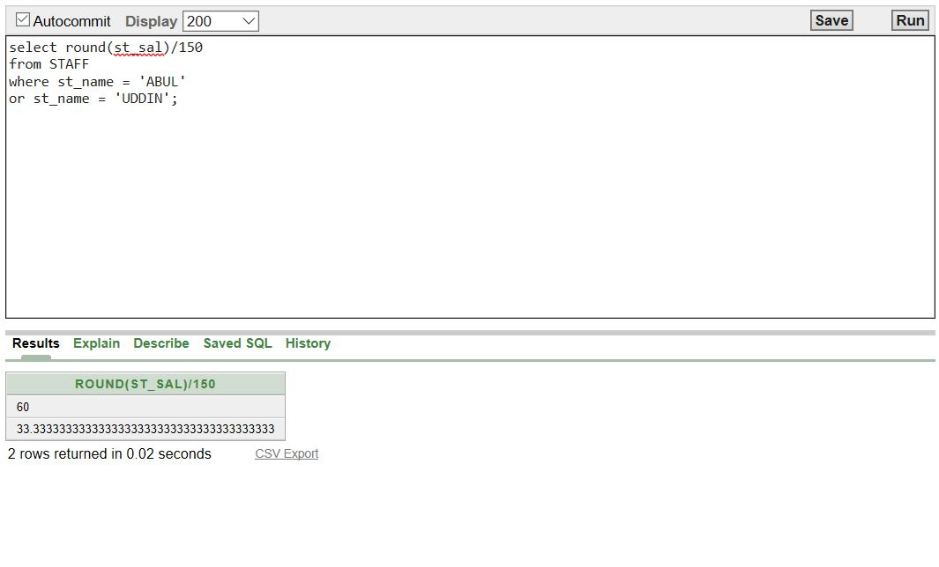

**2) Display the joindate of all trainer in the format DD-MONTH-YEAR(e.g 17 December Nineteen Eighty) and label the column JOIN_DATE?**

**Answer:**

**SELECT t_name,**

**TO_CHAR(t_join, 'fmDD Month Year') JOIN_DATE**

**FROM TRAINER;**

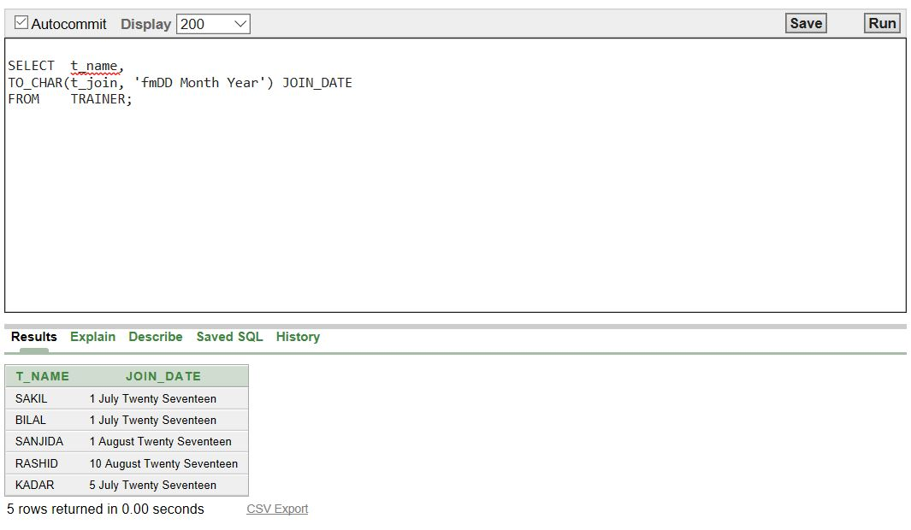

**##GROUP FUNCTION QUERIES:**

**3) Display the number of client whose gender is FEMALE and label the column GENDER?**

**Answer:**

**SELECT COUNT(c_gen) as GENDER**

**FROM CLIENT**

**WHERE c_gen = 'Female';**

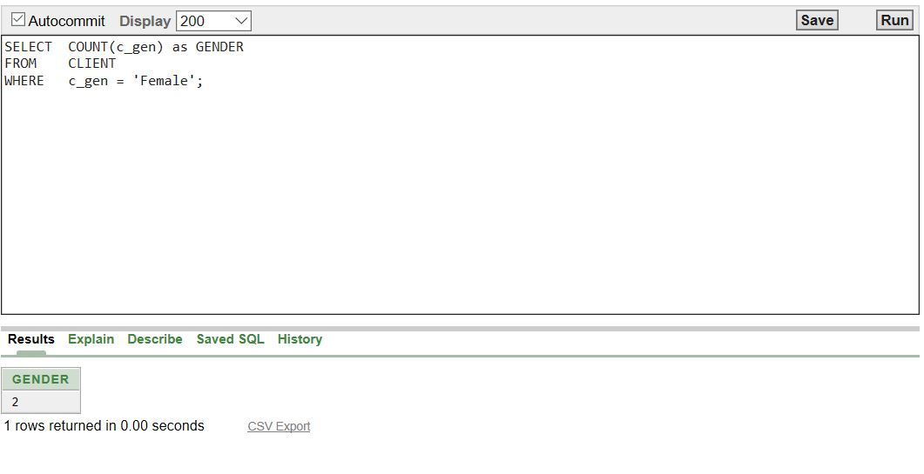

**4) Display the sum of salaries grouped by the satff id and role but the sum of salary must be greater than 8500?**

**Answer:**

**select sum(st_sal) as "SUM"**

**FROM STAFF**

**group by st_id, st_role**

**having sum(st_sal)>8500;**

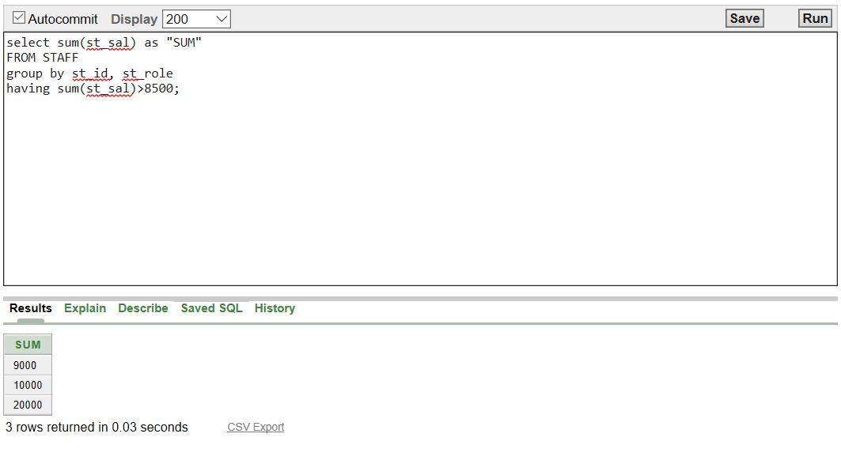

**##SUB QUARIES:**

**5) Display the Client details who joined after MANIK?**

**Answer:**

**SELECT \***

**FROM CLIENT**

**WHERE C_JOIN > (SELECT C_JOIN**

**FROM CLIENT**

**WHERE C_NAME ='MANIK');**

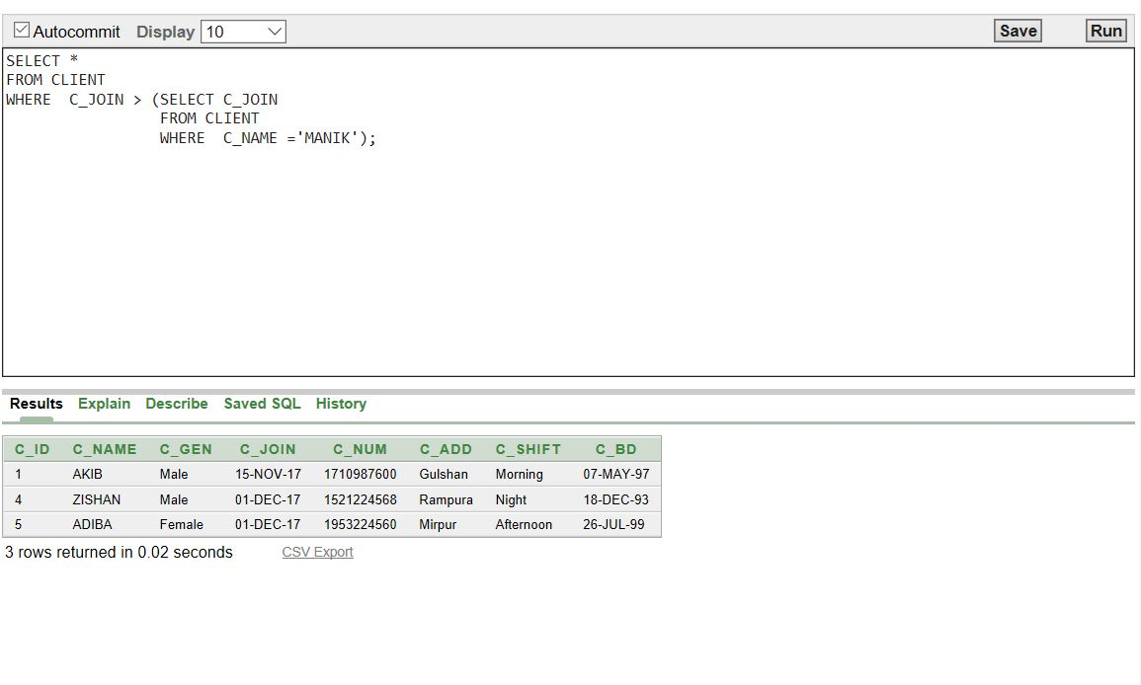

**6) Find the name, address and number of the Staff who get highest paid salary?**

**Answer:**

**SELECT st_name, st_add, st_num**

**FROM STAFF**

**WHERE st_sal>=ALL(SELECT st_sal**

**FROM STAFF);**

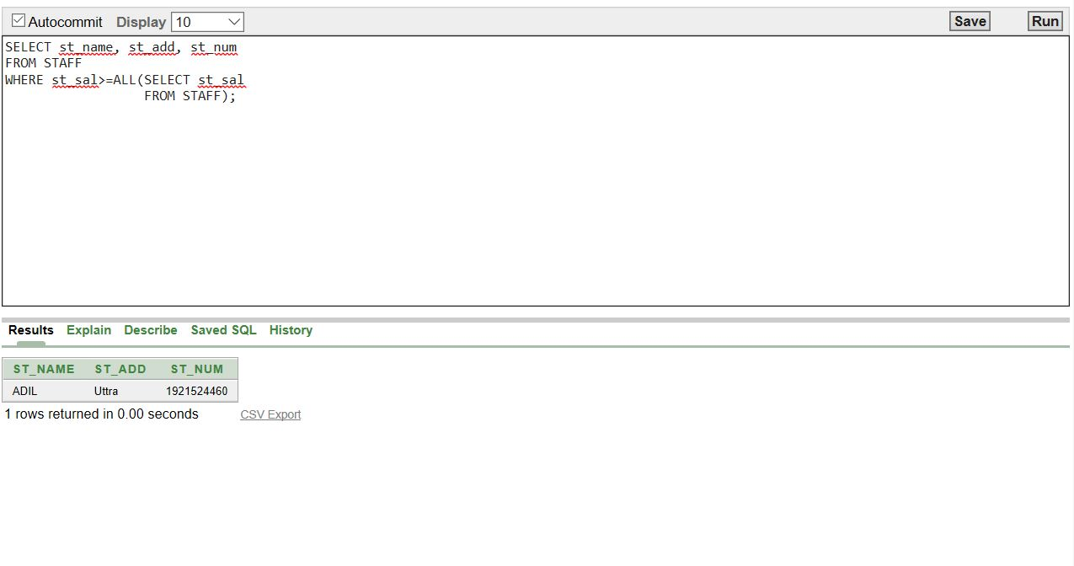

**7) Find the payment id and amount who of lowest payment holder?**

**Answer:**

**SELECT p_id, p_amou**

**FROM PAYMENT**

**WHERE p_amou =**

**(SELECT MIN(p_amou)**

**FROM PAYMENT);**

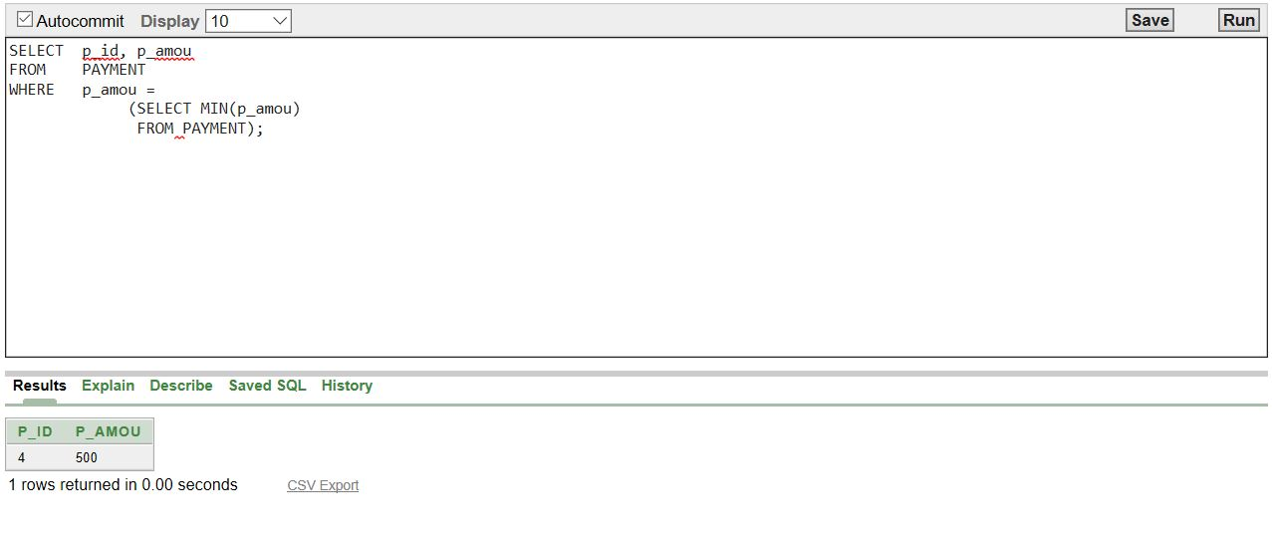

**##JOINING QUERIES:**

**8) Find the client name, address and shift who use locker 2?**

**Answer:**

**select client.c_name, c_add, c_shift**

**from client, locker**

**where client.c_id=locker.c_id and client.c_id=2;**

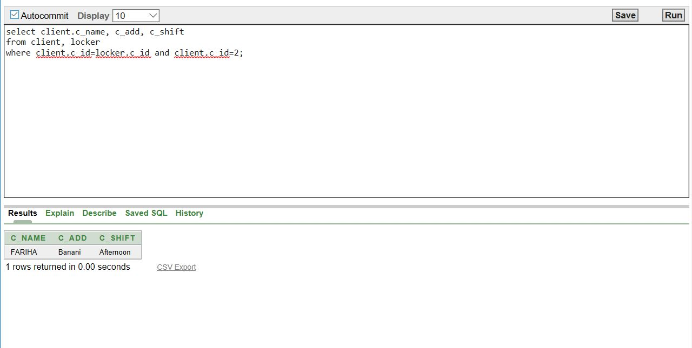

**9) Find the client name and deit unit who eat food item BANANA?**

**Answer:**

**select client.c_name, diet.d_unit**

**from client, diet, food**

**where client.c_id=diet.c_id and diet.f_id=food.f_id and food.f_name='Banana';**

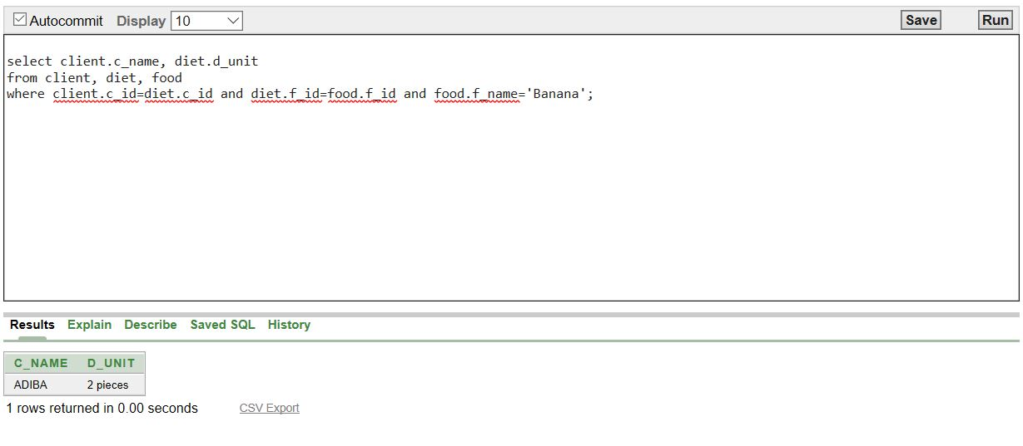

**10) Find the trainer name, address and number who is special skill for SPLIT?**

**Answer:**

**select Trainer.t_name, trainer.t_num, trainer.t_add**

**from trainer, trainer_skill, skill**

**where trainer.t_id=trainer_skill.tr_id and trainer_skill.sk_id=skill.sk_id and skill.sk_name = 'Split';**

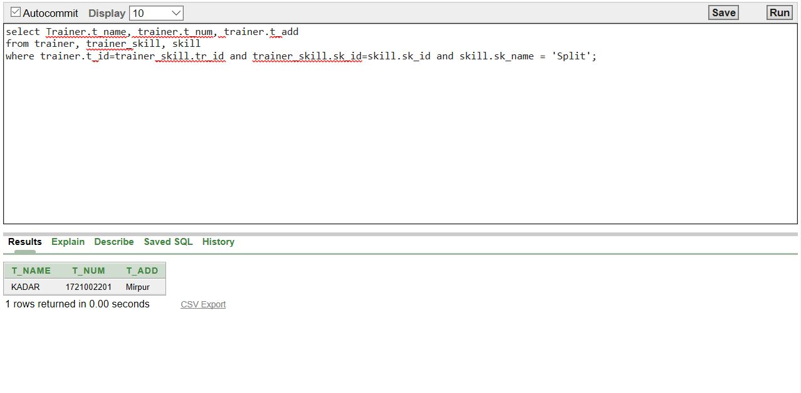

**Conclution:**

Our project is about a gym management system. We think our project will be very helpful to maintaining a gym. But we also have to say that it’s not complete. There are still scope for the advancement. After the advancement it will be better and better. We know that there are no perfect thing. So if we get enough chance we hope that we can make it better. We can also add it with a gym management software to complete it. We only use oracle software here so if we want to really make it useable we have to add it with a software. Then we can use the user interface and the other things. With that it will be truly ready for the use.